kubernetes task 03
- Create a ClusterIP service for an Apache web server pod.
  - check the nodes are ready
  - #kubectl get nodes
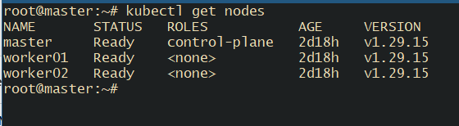
Create one yml file to create one cluster ip service
apiVersion: v1 / kind: Service
Declares a Kubernetes Service resource.

metadata.name: firstservice
The Service will be called firstservice.

spec.type: NodePort
Exposes the Service on a static port on every node’s IP.
Traffic can reach it via:

NodePort range
Default allowed range: 30000–32767
Container is listening on port 80
Make sure your Pod/container exposes and listens on port 80
---yaml —
apiVersion: v1
kind: Service
metadata:
name: firstservice
spec:
type: NodePort
ports:
- nodePort: 32000
port: 9000
targetPort: 80
selector:
type: app
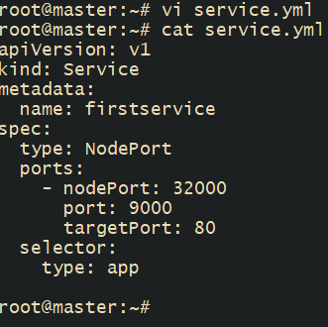

# kubectl create -f service.yml -- > create the service using yml file

#kubectl get services - - > list the services
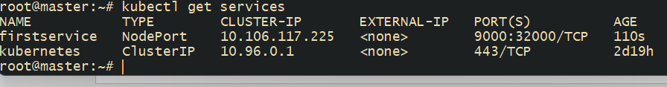

- Expose an Nginx pod externally using a NodePort service.
Write an yml file
---yml---
apiVersion: v1
kind: Pod
metadata:
name: mypod
labels:
type: app
spec:
containers:
- name: web
image: nginx
ports:
- containerPort: 80

#kubectl apply -f nginx-pod.yaml
#kubectl get pods
#kubectl describe pod <pod_name>
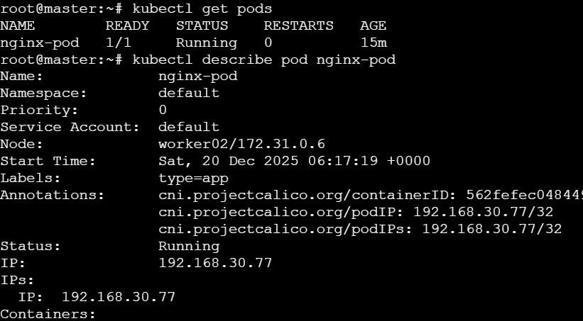

Check on browser with worker 02 : <public_ip>:32000


- Deploy a ReplicationController to maintain 3 replicas of an Nginx pod.
Replciation controller or RC will ensure that these many pods are running on the cluster.
For any reason if the pod is down then RC will monitor that and spin up a new pod for us.
RC will get attached to the pods based on labels and selectors.
Create RC YAML
vi nginx-rc.yaml

apiVersion: v1
kind: ReplicationController
metadata:
name: nginx-rc
spec:
replicas: 3
selector:
app: nginx
template:
metadata:
labels:
app: nginx
spec:
containers:
- name: nginx
image: nginx
ports:
- containerPort: 80
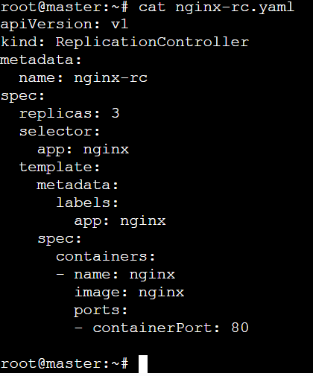

#kubectl apply -f nginx-rc.yaml

Verify:

#kubectl get rc
#kubectl get pods
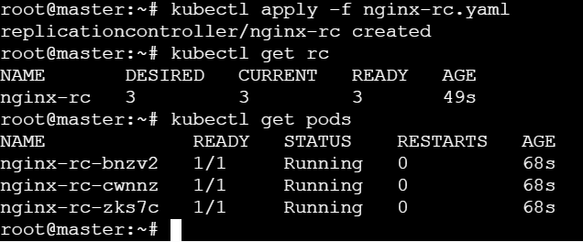
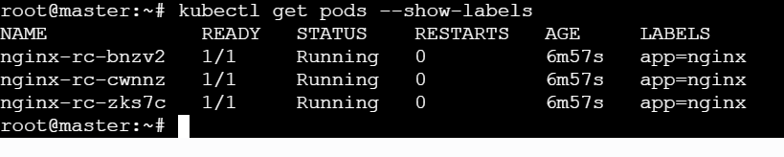
- Scale the ReplicationController from 3 replicas to 5 replicas.
#kubectl scale rc nginx-rc --replicas=5
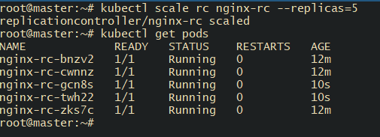
#kubectl delete nginx-rc-cwnnz – delete the pod
#kubectl get pods – check again you can see the another pod is created automatically by rc.
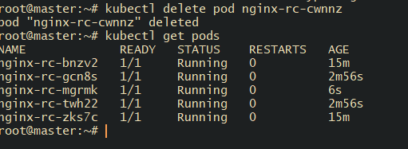
- Create a ReplicaSet to manage pods based on multiple labels (prod and test).
#vi multi-label-rs.yaml
apiVersion: apps/v1
kind: ReplicaSet
metadata:
name: multi-label-rs
spec:
replicas: 3
selector:
matchExpressions:
- key: env
operator: In
values:
- prod
- test
template:
metadata:
labels:
env: prod
spec:
containers:
- name: nginx
image: nginx
# kubectl apply -f multi-label-rs.yaml
# kubectl get rs
#kubectl get pods --show-labels
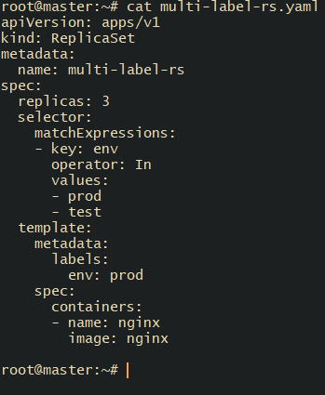
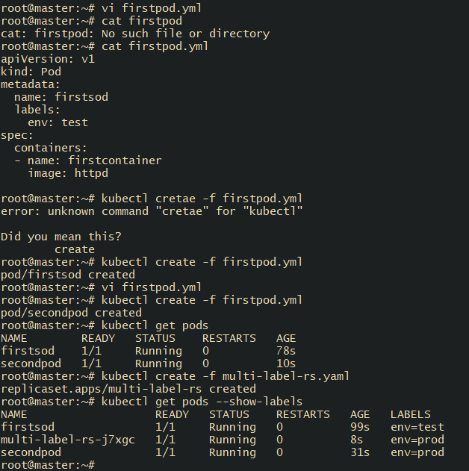

- Deploy a ReplicaSet that excludes pods with the label backend.
#vi exclude-backend-rs.yaml
apiVersion: apps/v1
kind: ReplicaSet
metadata:
name: exclude-backend-rs
spec:
replicas: 2
selector:
matchExpressions:
- key: role
operator: NotIn
values:
- backend
template:
metadata:
labels:
role: frontend
spec:
containers:
- name: nginx
image: nginx
# kubectl apply -f exclude-backend-rs.yaml
# kubectl get pods –show-labels
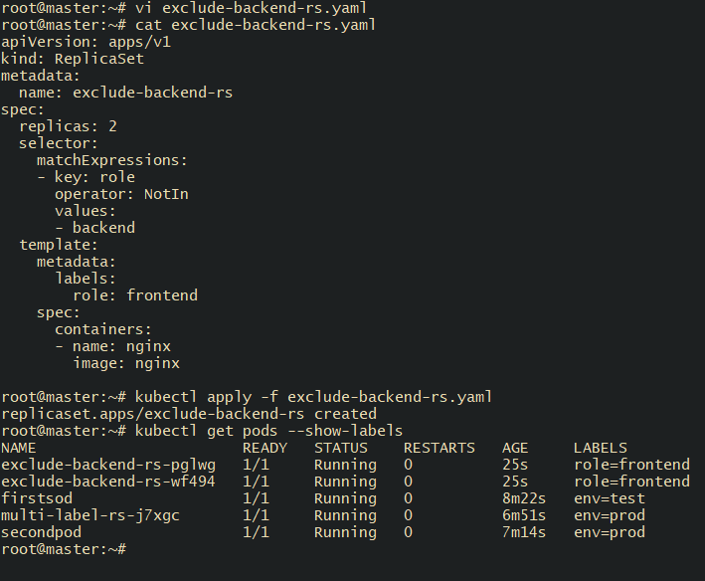

- Test load balancing across multiple pods using a NodePort service.
# kubectl expose rs nginx-rc \ --name=nginx-lb \ --port=80 \ --type=NodePort expose replica set
# kubectl get svc nginx-lb check node port
# curl http://<Node-IP>:<NodePort> check load balancer
# vi service.yml
apiVersion: v1
kind: Service
metadata:
name: echo-service
spec:
type: NodePort
selector:
app: echo-server
ports:
- port: 80
targetPort: 5678
nodePort: 30080

# vi deployment.yml
apiVersion: apps/v1
kind: Deployment
metadata:
name: echo-server
spec:
replicas: 3
selector:
matchLabels:
app: echo-server
template:
metadata:
labels:
app: echo-server
spec:
containers:
- name: echo
image: hashicorp/http-echo
args:
- "-text=Hello from pod: $(POD_NAME)"
env:
- name: POD_NAME
valueFrom:
fieldRef:
fieldPath: metadata.name
ports:
- containerPort: 5678
.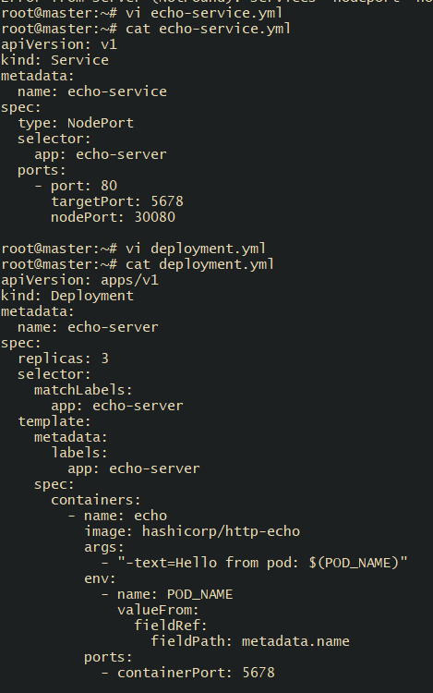

# kubectl apply -f echo-deployment.yaml
# kubectl apply -f echo-service.yaml
# kubectl get svc echo-service
#kubecctl get endpoints echo-service
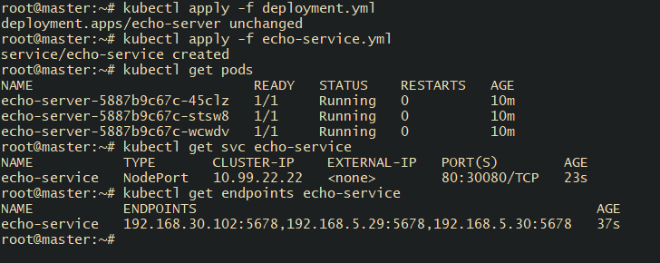

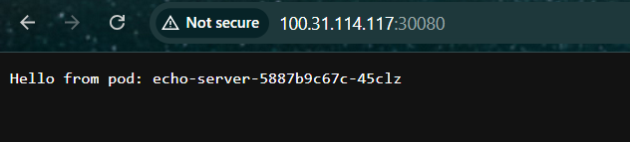

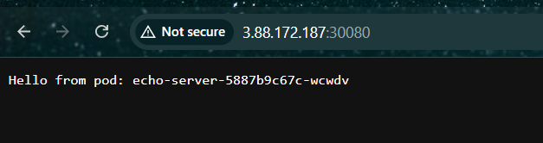

- Delete a ReplicationController without affecting the running pods.
# kubectl delete rc nginx-rc --cascade=false
# kubectl get pods
# kubectl get rc
Pods remain running
Useful for migration from RC → Deployment
